Laboratory 1

Transmission Lines and LAN Cable Meter

Abstract:

A characteristics and performance test was made on the RG-59 coaxial cable and the 10Base-T multi-wire cable. Each cable is longer than 50 feet where they each have impedances of 75Ω and 100Ω respectively. The FLUKE 650 LAN Cable Meter, FLUKE DSP-2000 Cable Analyzer, and FLUKE Networks Cable IQ Qualification Test were all used to classify wire fidelity and impedance. Measurements were made on “Black Boxes” with the 10Base-T to check their connectivity and TDR measurements were made with the RG-59 cable with a variety of extensions and terminations including the RG-58 short cable, a short circuit termination, and a load termination. Lastly, the L and C of the cables were measured on the lab’s LCR meter.

Part I

1. Long Cable Test

The 10Base-T Cable was evaluated using the FLUKE Networks Cable IQ Qualifications Tester. One end was connected to the device and the other to a wiremap adapter. A passed autotest indicated the following results:

Length: 16.2m

2. “Black Box” wiremap examiniation

The 10Base-T Cable was then connected to a variety of “Black Boxes” to check for issues in connectivity.

Box 1: No errors, Length: 18.6m

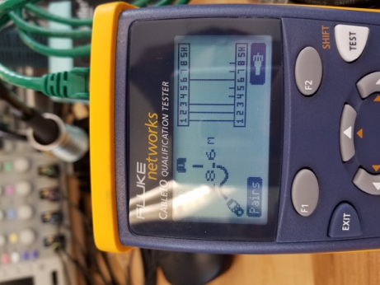

Box 2: Broken connection at port 1, Length: 19.1m

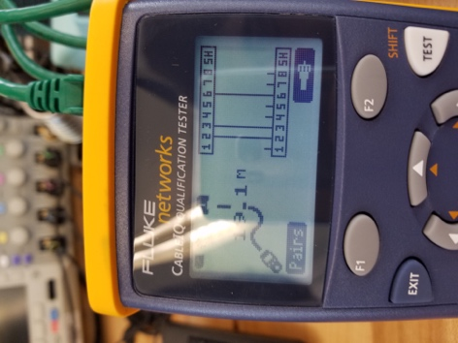

Box 3: Short from 1 to 2, Length: 19.1m

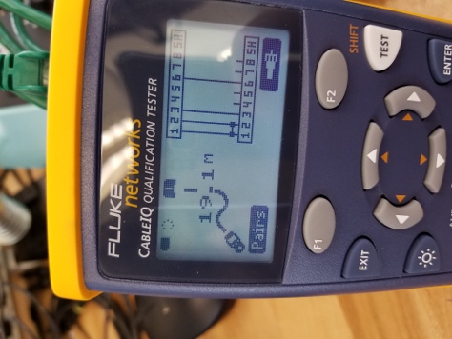

Box 4: Cross between ports 1 and 2, Length: 18.6m

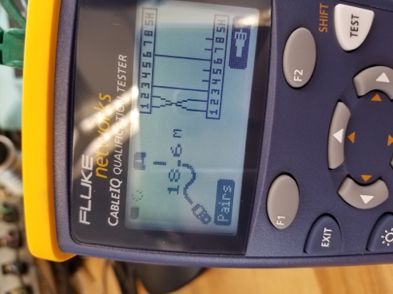

Box 5: Cross between ports 1 and 3, Cross between ports 2 and 6, Length: 18.6m

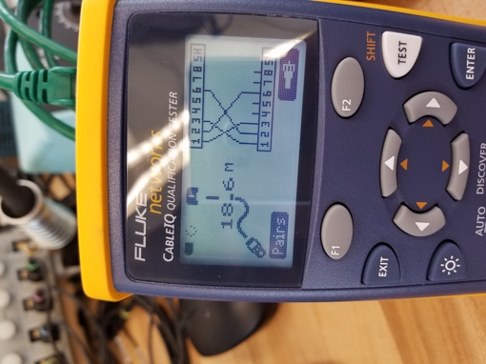

3. 10Base-T Cable impedance measurement using FLUKE DSP-2000 Cable Analyzer

Wire Length: 15.7m

Resistance: 2.3Ω for both

Propagation Delay: 1&2 = 76ns; 3&6 = 78ns

Impedance: 1&2 = 104Ω; 3&6 = 101Ω

Attenuation: 10.4

The values are the same for each pair except for the propagation delay and the impedance. The difference in impedance can be attributed to small differences in length or connection quality. The difference in propagation delay is directly related to the propagation speed of an EM wave. That speed is directly related to the impedance, so it follows that the propagation delay varies along with the impedance.

Part 2:

TDR Plots for corresponding configurations

RG-59 + open circuit

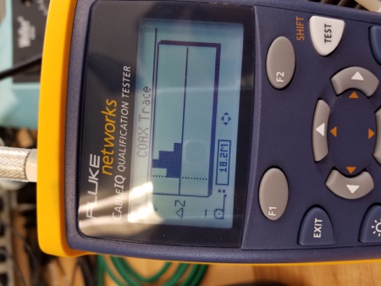

RG-59 + short circuit

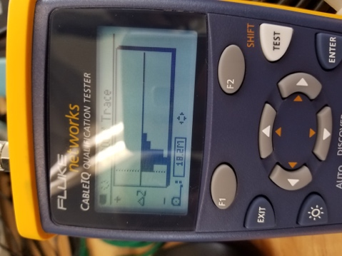

RG-59 + load

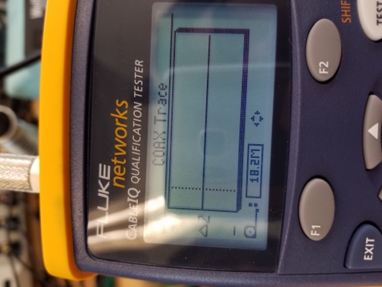

RG-59 + RG-58 + open

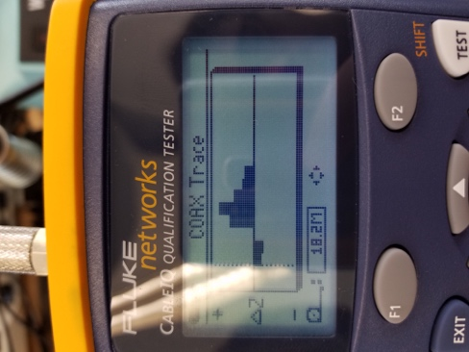

RG-59 + RG-58 + short

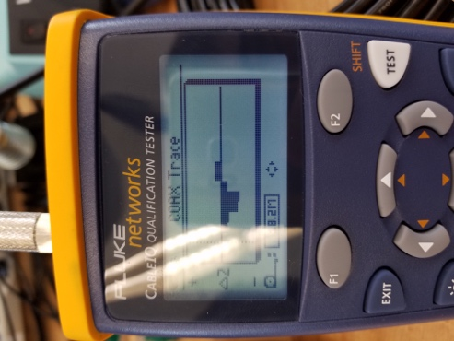

RG-59 + RG-58 + load

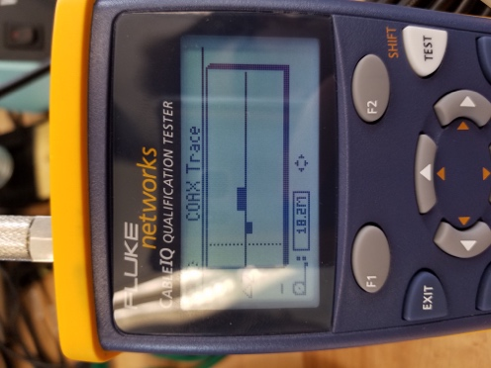

RG-59 + RG-174

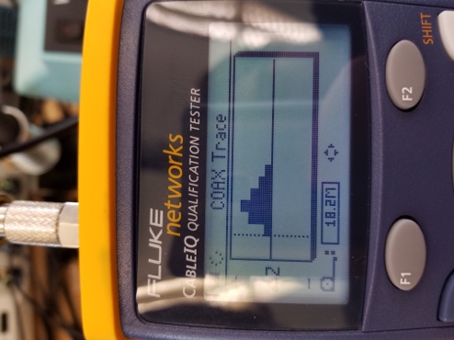

This reading indicates that this is a wire. If this were a cable, the reading would indicate that the cable was longer than the previous measurements. This plot also looks like a longer version of the RG-59 with an open circuit configuration.

TDR Plots for the resistor, capacitor, diode, and inductor

Resistor

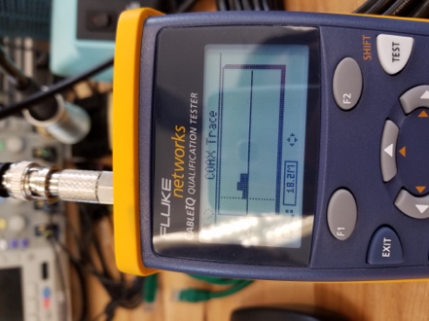

The small change in load impedance indicates that there is a section of the circuit whose impedance does not change so much with accordance to EM waves, which makes sense considering this is a resistor.

Capacitor

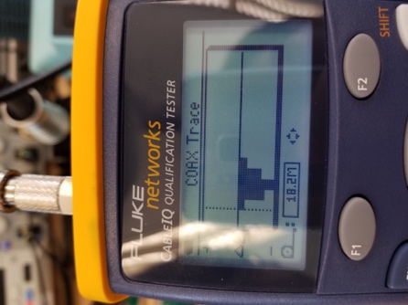

This result is a negative reflection of the load change when the cable is just open. This makes sense as a quick pulse makes the circuit seem as though it is short circuited due to the uncharged capacitor. This result looks very similar to that of the RG-59 with a short circuit in the previous section.

Diode

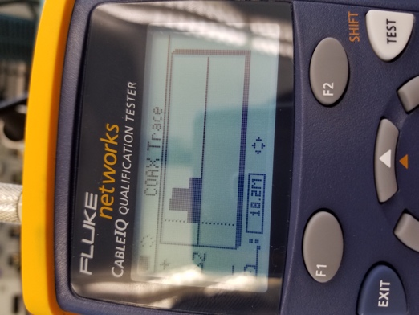

This result is rather foreign as no component previously measures emulates the characteristics of the diode. This curve seems to be almost truncated. Most of the other readings have relatively smooth curves. The change in impedance seems to stop in the middle of the reading. This can be due to the diode turning on an suddenly acting like a short, where before it acted as an open.

Inductor

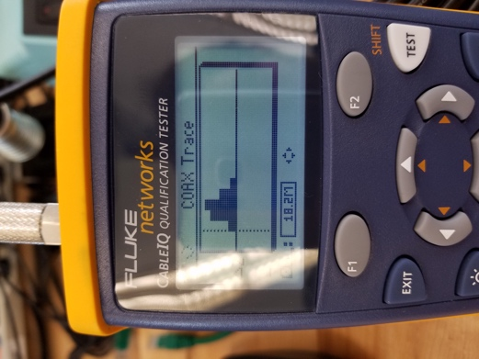

This result matches the open circuit configuration in the previous section. This makes sense as an inductor in a circuit acts as an open loop when only a short pulse is given to the circuit. Therefore, the reading should see an open and communicate that reaction, which it did.

Part 3

Length: 17.5m

Impedance: 80Ω

Resistance: 5.4Ω

There is a slight difference in the length values of the previous measurements. These readings find a longer length then the previous measurements.

Box Impedance Measurements:

Box 11: 73.7Ω

Box 16: 5.4Ω

Box 17: 28.9Ω

Part 4

RG-59

Capacitance: 1.03 nF

Inductance: 0.9 H

10Base-T

Capacitance: 1.41nF

Inductance: .57 H

\*My calculated results were way off, and this was verified with the TA’s. The measured results are as expected.